10th IWM at Kyoto Times New Roman 12 pt bold

Kyoto Japan,^{1*} Miyako Messe,² Times New Roman 11 pt,¹ and Micro Plasma²

¹ Historical city, Times New Roman 11pt Italic, address, Japan
² Graduate School of Microplasma, Plasma University, address, Japan
*E-mail: iwm10@plasma.k.u-tokyo.ac.jp

Please provide your abstract as a one-page pdf file. The maximum file size is 10 MB. No page number should be inserted. The margins should be 35.1 mm on the top and 30 mm for the others (right, left, and bottom).
Times New Roman (or similar font) should be used. Use bold 12pt for title, and 11pt for the others. Underline the presenter’s name. The address and e-mail address should be in Italic.
You can include images. Since we are planning to provide abstracts as a pdf file, color images/figures can be used [1].

See you in Kyoto!!!

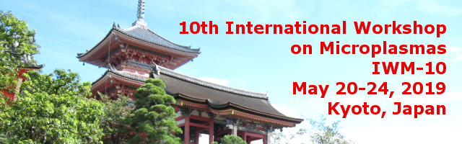
Fig. 1 Picture of Kiyomizu temple.

[1] M. Plasma and K. Kyoto, J. Microplasma 10, 420 (2019).

